**Development of an electronic stethoscope to record heart and lung sounds.**

*By*

***Shreenandan Sahu***

*(Roll NO:* ***CL24M013)***

*Under the guidance of*

***Dr. Anand Bhaskar***



*July 2025*

*Department of Bioengineering*

**Christian Medical College Vellore**

# **Abstract**

This project presents a fully functional electronic stethoscope system developed to record, filter, and visualize heart and lung sounds using accessible and low-cost components. A condenser microphone was mechanically interfaced with a traditional stethoscope chest piece via a custom 3D-printed adapter. The acquired acoustic signals are amplified and passed through an analog bandpass filter (20–500 Hz or 100-1500 Hz) to isolate physiological sounds of interest. The output is routed via dual 3.5 mm audio jacks—one for real-time listening and another for simultaneous recording into a PC or mobile device.

A custom-built Python software interface was developed to capture, digitally filter, and visualize the recorded sound signals, providing a complete auscultation toolchain. The software supports real-time waveform plotting, playback, and file storage, making it suitable for both educational and clinical applications. The final device is compact, portable, and cost-effective, demonstrating its potential for medical training, telemedicine, and resource-limited healthcare settings.

***Keyword: Electronic Stethoscope, Heart Sounds, Lung Sounds, Bandpass Filter, Signal Amplification, Python GUI, Biomedical Signal Acquisition***

**Contents**

**Abstract** 2

**Figure List** 4

**Chapter 1: Introduction** 5

**1.1.** **Origin of Stethoscope and the Need for Digital Evolution** 5

**1.2.** **Aim and Objectives** 5

**Chapter 2: Literature Review** 6

**2.1.** **Understanding Stethoscope Parameters** 6

**2.2.** **Understanding and comparing available devices** 7

**Chapter 3: Materials and Methods** 8

**3.1.** **Device Fabrication:** 8

**3.1.1.** **Ideation of the device.** 8

**3.1.2.** **Stethoscope Adaptor Design** 8

**3.1.3.** **Stethoscope Circuit Design** 9

**3.1.4.** **Stethoscope Circuit Enclouse Design** 11

**3.1.5.** **Stethoscope Recording Software** 12

**3.1.6.** **Concluding the build** 13

**Chapter 4: Results and Discussion** 14

**4.1.** **Final assembled device:** 14

**4.2.** **Testing of the Device:** 14

**4.2.1.** **Oscilloscope Based Amplification Testing.** 14

**4.2.2.** **Recorded Sound based Frequency Testing.** 15

**Chapter 5: Conclusion** 16

**5.1** **Summery:** 16

**Design and Development:** 16

**Validation and Testing:** 16

**5.2** **Conclusion:** 16

**Chapter 6: Future Scopes** 17

**Chapter 7: Learnings from the project** 18

**Figure List**

**Figure 1 Stethoscope Adaptor Design (Sketchup)** 9

**Figure 2 Schematics of the device (KiCAD)** 10

**Figure 3 PCB layout of the device (KiCAD)** 10

**Figure 4 Final PCB layout 3D rendered. (KiCAD)** 11

**Figure 5 Enclosure of the device Rendered (SKetchUp)** 11

**Figure 6 Static and Operation view of the compatible software** 12

**Figure 7 The entire PCB after mounting all the components.** 13

**Figure 8 Developed device with all the components of it.** 14

**Figure 9 Base Sound VS Amplified sound from the Oscilloscope** 15

**Figure 10 Audacity based spectrogram viewer for the recorded sound analysis.** 15

# **Chapter 1: Introduction**

* 1. **Origin of Stethoscope and the Need for Digital Evolution**

Origin of the Stethoscope and the Need The stethoscope, first introduced by René Laennec in 1816, was designed as a non-invasive tool to listen to internal body sounds, primarily for assessing the heart, lungs, and airways. Over the decades, it became an indispensable instrument in physical examinations, helping clinicians diagnose cardiovascular and respiratory conditions through chest auscultation. Despite its simplicity and effectiveness, the traditional acoustic stethoscope is limited by its reliance on the clinician’s auditory acuity and the absence of recording or amplification capabilities.

With the increasing demand for precise, reproducible, and remote diagnostic tools, the need for digital and electronic stethoscopes has grown significantly. These advanced devices enable amplification, filtering, and real-time visualization of internal sounds, allowing for better detection of subtle abnormalities. Moreover, the integration of recording features, data storage, and connectivity to mobile applications enhances their utility in telemedicine, clinical training, and longitudinal monitoring. In this evolving healthcare landscape, digital stethoscopes are not just upgrades—they are essential tools bridging traditional auscultation with modern diagnostic need for Digital Evolution.

* 1. **Aim and Objectives**
* Captures heart and lung sounds by interfacing a traditional stethoscope chest piece with a condenser microphone.
* Amplifies the low-level physiological signals using custom-designed analog circuits.
* Filters out background noise using hardware-based bandpass filters to retain only relevant frequencies.
* Transmits the processed sound to a computer or mobile device through a 3.5 mm audio jack for real-time listening.
* Records and saves the audio using custom-built or open-source software for further analysis and documentation.

# **Chapter 2: Literature Review**

* 1. **Understanding Stethoscope Parameters**

A stethoscope is a fundamental auscultation tool used to detect internal body sounds, primarily from the heart and lungs. The design and functionality of both traditional and electronic stethoscopes are based on the acoustic characteristics of these physiological sounds. Understanding the typical frequency ranges and signal properties of heart and lung sounds is essential for designing effective electronic stethoscope systems.

Heart sounds typically fall within a low-frequency range of 20 to 150 Hz. The first heart sound (S1) and second heart sound (S2) are the most prominent and are caused by the closing of the atrioventricular and semilunar valves, respectively. Abnormal heart sounds such as murmurs, gallops, or clicks may extend slightly beyond this range but remain in the low-frequency domain. Due to their low amplitude and frequency, heart sounds require high-gain amplification and careful filtering to be captured clearly without distortion.

Lung or respiratory sounds, on the other hand, span a broader frequency range, typically from 100 to 1000 Hz, with some components reaching up to 2000 Hz in pathological conditions such as wheezing or crackles. Vesicular breath sounds, which are normal lung sounds heard during inhalation, usually occupy the lower end of this range, while bronchial or adventitious sounds may be of higher frequency and diagnostic significance.

Electronic stethoscope design must consider these parameters to ensure proper signal acquisition, amplification, and filtering. Bandpass filters are often set between 20–500 Hz to cover both heart and the lower range of lung sounds while minimizing environmental noise and irrelevant high-frequency components. Proper impedance matching, microphone sensitivity, and gain settings are also crucial to optimize signal clarity and reduce distortion or loss.

By tailoring these technical parameters to the physiological sound characteristics, modern electronic stethoscopes can provide clear, accurate audio output, making them useful not only for real-time diagnosis but also for recording, telemedicine, and machine-learning-based auscultation support.

* 1. **Understanding and comparing available devices**

Over the past decade, several commercial electronic and digital stethoscopes have emerged, offering enhanced auscultation features like real-time visualization, sound amplification, and wireless data transfer. These advancements aim to overcome the limitations of traditional acoustic stethoscopes, such as low sound clarity, no recording options, and challenges in remote sharing for teleconsultation and teaching.

The Littmann® Electronic Stethoscope (Model 3200) is a well-known example, providing up to 24x amplification, Bluetooth connectivity, and PC software integration. However, with a price of ₹35,000–₹45,000 INR ($400–$550 USD), it is often unaffordable in low-resource settings. The Eko Core Digital Attachment converts standard stethoscopes into digital ones, offering features like mobile app visualization and AI-based sound analysis, but still costs ₹25,000–₹30,000 INR ($300–$360 USD). Wearable systems like StethoMe® and Clinicloud go a step further with fully wireless monitoring, but also require subscriptions and typically cost above ₹20,000 INR ($250 USD).

While these devices offer advanced functionality, their high cost, limited accessibility, and closed-source nature limit their adoption in underserved regions. This creates a clear need for low-cost, open-source alternatives. Devices that offer basic auscultation functions—like amplification, filtering, and recording—can be built for as little as ₹1,500–₹2,000 INR ($20–$25 USD), making them ideal for training and community healthcare.

This project addresses that need, providing a cost-effective, open-design electronic stethoscope with essential features and a user-friendly software interface for real-world and educational use.

# **Chapter 3: Materials and Methods**

* 1. **Device Fabrication:**
     1. **Ideation of the device.**

The device is designed as an attachable module to a traditional stethoscope chest piece. It incorporates adaptive noise cancellation using two microphones—one as the primary microphone for capturing chest sounds and the other as a reference microphone to detect ambient noise, enabling effective background noise reduction. Both microphones will be housed within a custom-designed enclosure, which will include proper acoustic sealing and a nozzle to securely connect the chest piece tubing.

The enclosure will also feature a 3.5 mm audio jack port to connect the device to an external recording or processing unit. The device will support two operational modes—Heart Mode and Lung Mode—selectable via a toggle switch, along with a volume adjustment control for user convenience.

Power will be supplied by two Li-Po batteries, providing up to 7.5V, and the device will include an integrated charging module. A power switch will control the device, and an LED indicator will illuminate when the system is powered on.

Upon receiving the input from the microphone assembly, the signal will be processed through a custom analog circuit designed for amplification and filtering to enhance the relevant frequency range (20–150 Hz for heart sounds, 100–1000 Hz for lung sounds). The filtered output will then be routed to two separate 3.5 mm output ports, enabling simultaneous real-time listening and recording.

This compact, sealed, and user-friendly design ensures ease of use, high-quality signal acquisition, and adaptability for both clinical and educational applications.

* + 1. **Stethoscope Adaptor Design**

Our aim is to make an adaptor to house 2 microphone and 3.5mm jack, apart from that it has a nozzle to conduct the sound from chest piece to the mics. The mics must place close to each other to capture the unwanted sounds equally so that it can be eliminated. The adaptor needs to be small but efficient. It should not conduct the movement sounds.

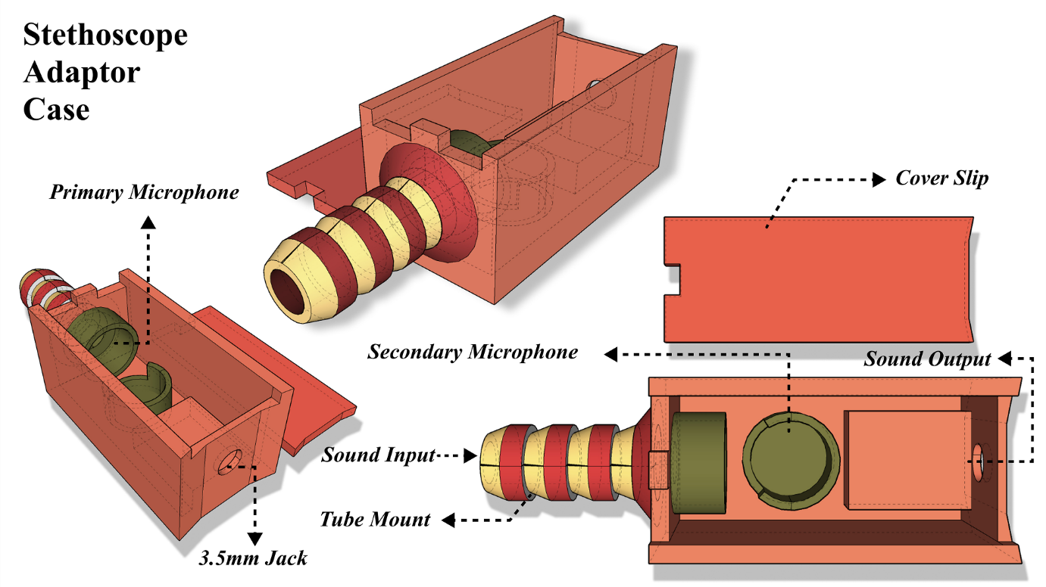

**Figure 1 Stethoscope Adaptor Design (Sketchup)**

* + 1. **Stethoscope Circuit Design**

The main backbone of the electronics circuit is the op-amp and the instrumentation amplifier which amplifies and filters out the signal. The main obstacle faced was to operate these op-amp in single power supply. After going though application reports form manufactures, we ended up with some configuration which has been implemented in the AFE board. We have gone with 6th order filters to clearly filter the upper frequencies. For the op-amps to properly run by a single supply we have used virtual ground with value equivalent to Vcc/2. This makes the amplification suitable and non-saturating as the waves are sinusoidal.

Instrumentation amplifier was used at the first stage to get differential output from the 2 mics with adaptive noise cancellation by using pression resistance. Once it was done it then passed through a 1st order high pass filter then it went through 5th order low pass filter. This cleaned and simultaneously amplified the signal to about 20 to 40 times the input signal. The user had an option to choose between the lung and heart sound via a toggle switch. Then the sound via a power amplifier goes to the 3.5mm jack for listening and recording.

A total of 6 op-amps are use and 1 INA is used to process the signal in the analog front end. The mics are electret mics which are biased via 1K ohm resistance. One of the opamp is used for half Vcc generation. Before the power supply is fed to the board its filtered. Overall, from start to end the stethoscope has total amplification of 80-100 times the input.

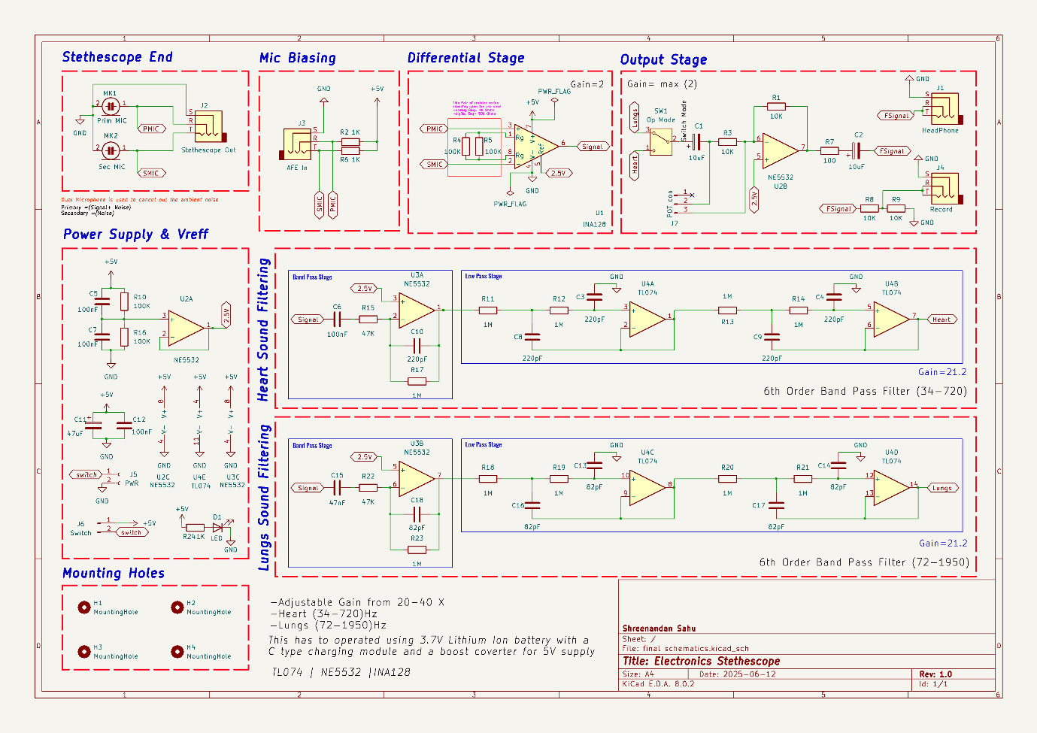

**Figure 2 Schematics of the device (KiCAD)**

The PCB is designed keeping the inputs in one side and the output to the other side which gives proper look to the enclosure and easy to use. The PCB has detachable ports for the power, switch and potentiometer. The PCB is designed keeping in mind the ease of operation.

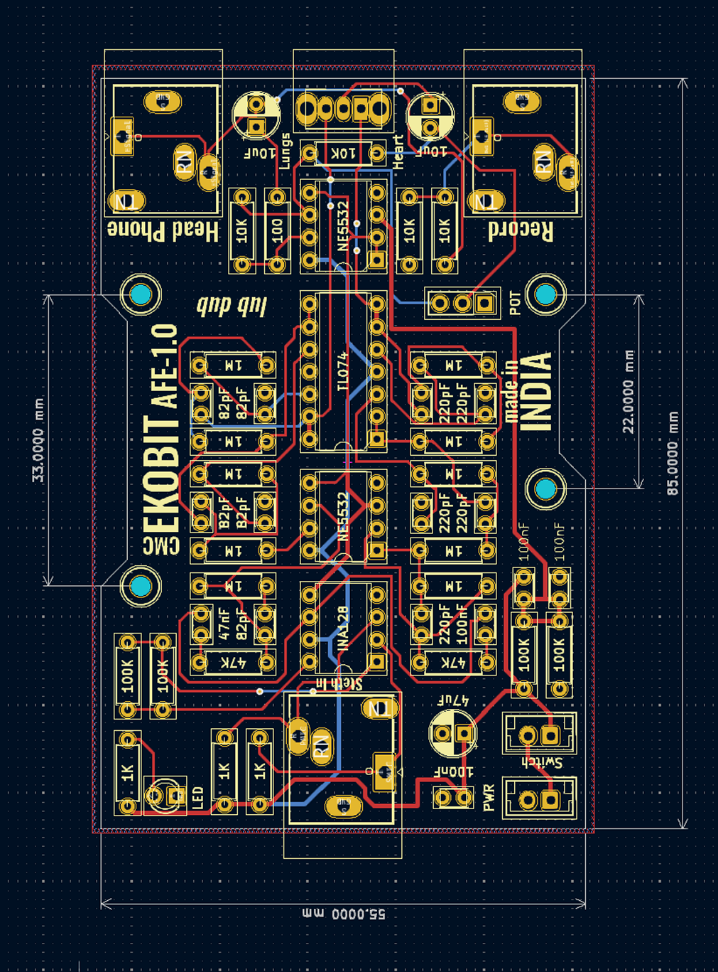

**Figure 3 PCB layout of the device (KiCAD)**

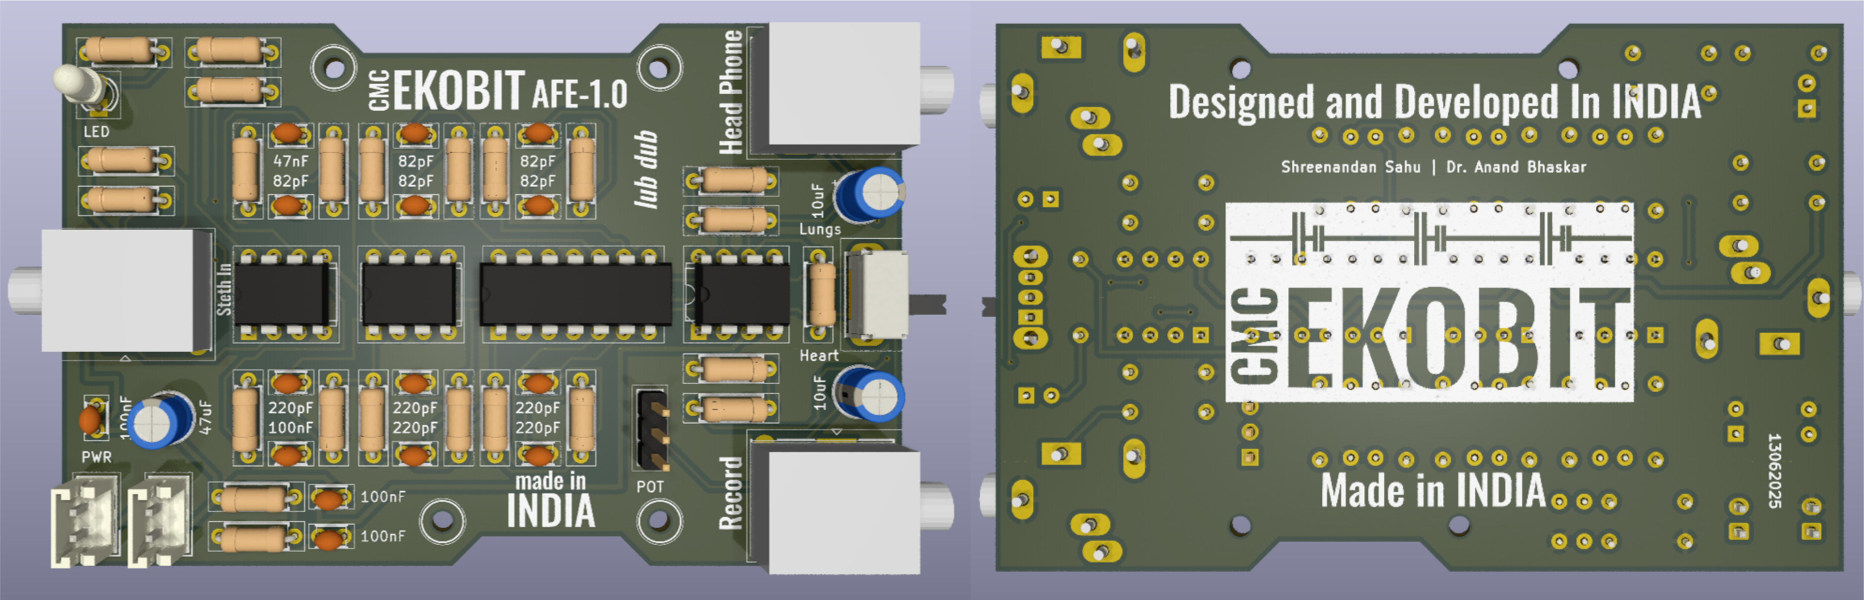

**Figure 4 Final PCB layout 3D rendered. (KiCAD)**

* + 1. **Stethoscope Circuit Enclouse Design**

The enclosure will house the entire circuit along with the accessories like the power switch, charging port, batteries, charging module, potentiometer, and the indicator LED. These components are stacked into 2 layers, bottom will have all the batteries and its peripheral along with the potentiometer on one side. The box size is mainly decided by the PCB. To mount the PCB we have designed edges to keep the PCB firmly on. For the inputs and output all the desired ports were made. Logo of the product was also engraved to one side and other parts were properly marked out. On top of everything we have a cover slip to enclose all once all the connections and parts are properly placed into the box.

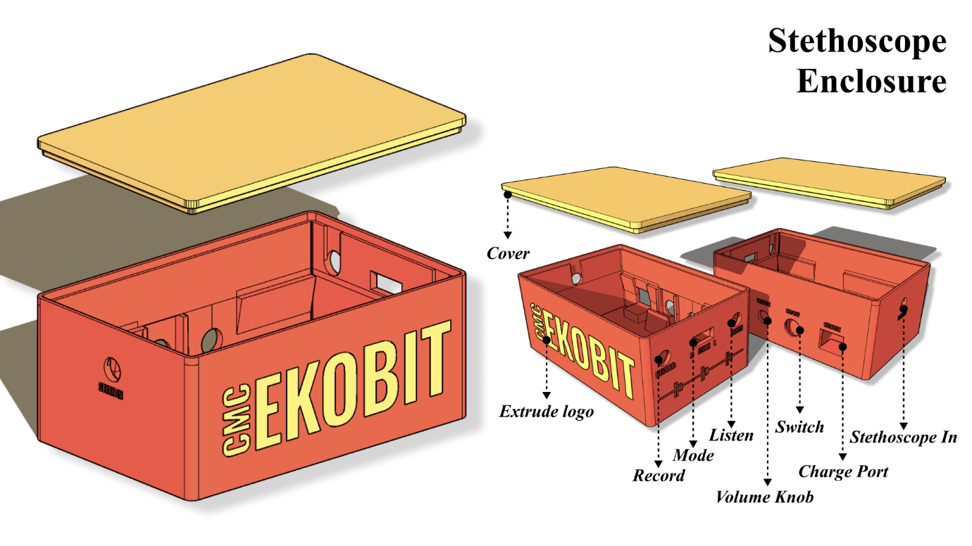

**Figure 5 Enclosure of the device Rendered (SKetchUp)**

* + 1. **Stethoscope Recording Software**

The heart and lung sound can be directly heard via the output using earphone but for the recording purpose we need to have some software interface. Although it can be directly recorded using 3.5 mm jack and any recording software and any device e.g., Mobile phones, Computers etc, but for best results and digital filtering we have built our own compatible software. The software allows us to record the sounds at 8KHz sampling frequency and has digital filter like notch filter at 50 Hz.

The software was written in Python and using libraries of python. It has basic and clean interface which allows us to use it smoothly. It has field for patient details, organ to be auscultated, filtering range and record time. It has file saving location option also. Visually it has the waveform viewer which shows the live unfiltered view of the sound input.

Once all the parameters are set and the software starts recording, it records for the duration and the saves it in the location and gives a confirmation pop up. It stores both the RAW and the filtered sounds in the same file location. Software can record with different parameter set by the user.

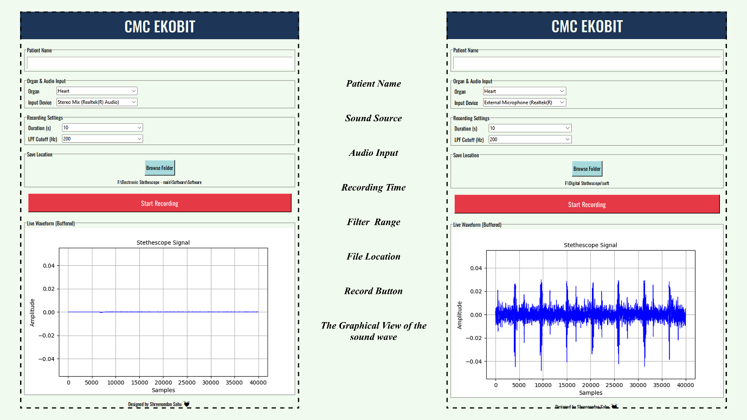

**Figure 6 Static and Operation view of the compatible software**

* + 1. **Concluding the build**

The device has mainly PLA as the prime material which was used in 3D printing. The entire dimension of the device is about (h-40mm, l-92mm, b-60mm). Device weighs up to about 150gms after all the components were placed inside the enclosure.

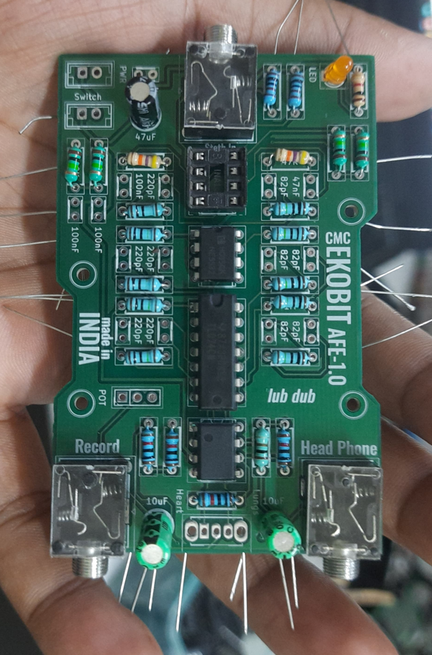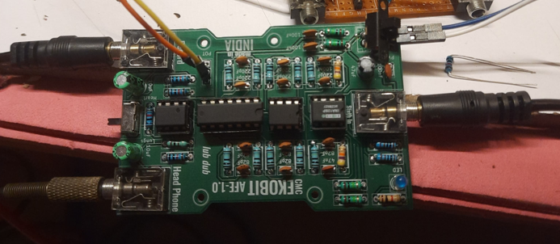

**Figure 7 The entire PCB after mounting all the components.**

***ALL THE RESOURCES ARE AVAILABLE IN THIS*** [***GITHUB***](https://github.com/shreenandansonu/Electronic-Stethescope) ***PAGE.***

***https://github.com/shreenandansonu/Electronic-Stethescope***

# **Chapter 4: Results and Discussion**

* 1. **Final assembled device:**

The device was successfully developed and designed. Proper offset was maintained for the proper fitting of the PCB into the enclosure. The Enclosure was built using 3D printer (Flash Forge) using PLA material of black and grey color. The adaptor must be placed inside a metallic plating to avoid the unwanted noises.

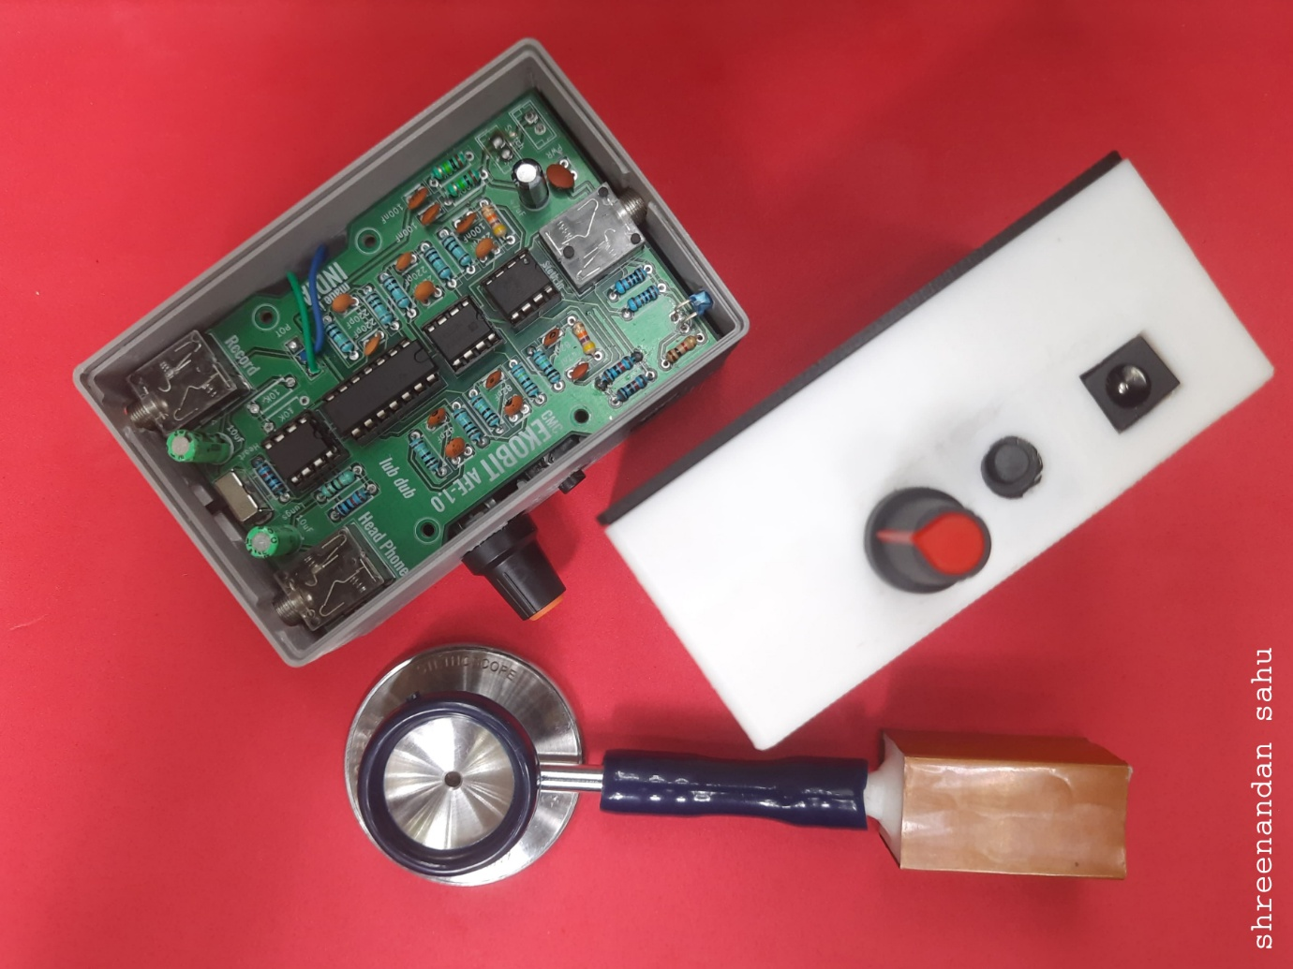

**Figure 8 Developed device with all the components of it.**

* 1. **Testing of the Device:**
     1. **Oscilloscope Based Amplification Testing.**

We have tested the device successfully using digital oscilloscope (Rigol DS1104). First, we tested the bare mic without amplification. That gave us results with our signal in the range of 120mV peak to peak. After the PCB was completely build, we tested it in the DSO, and it gave us acceptable signal range of around 1740mV. That shows that the device amplified the signal properly without distortion (with adjusted volume).

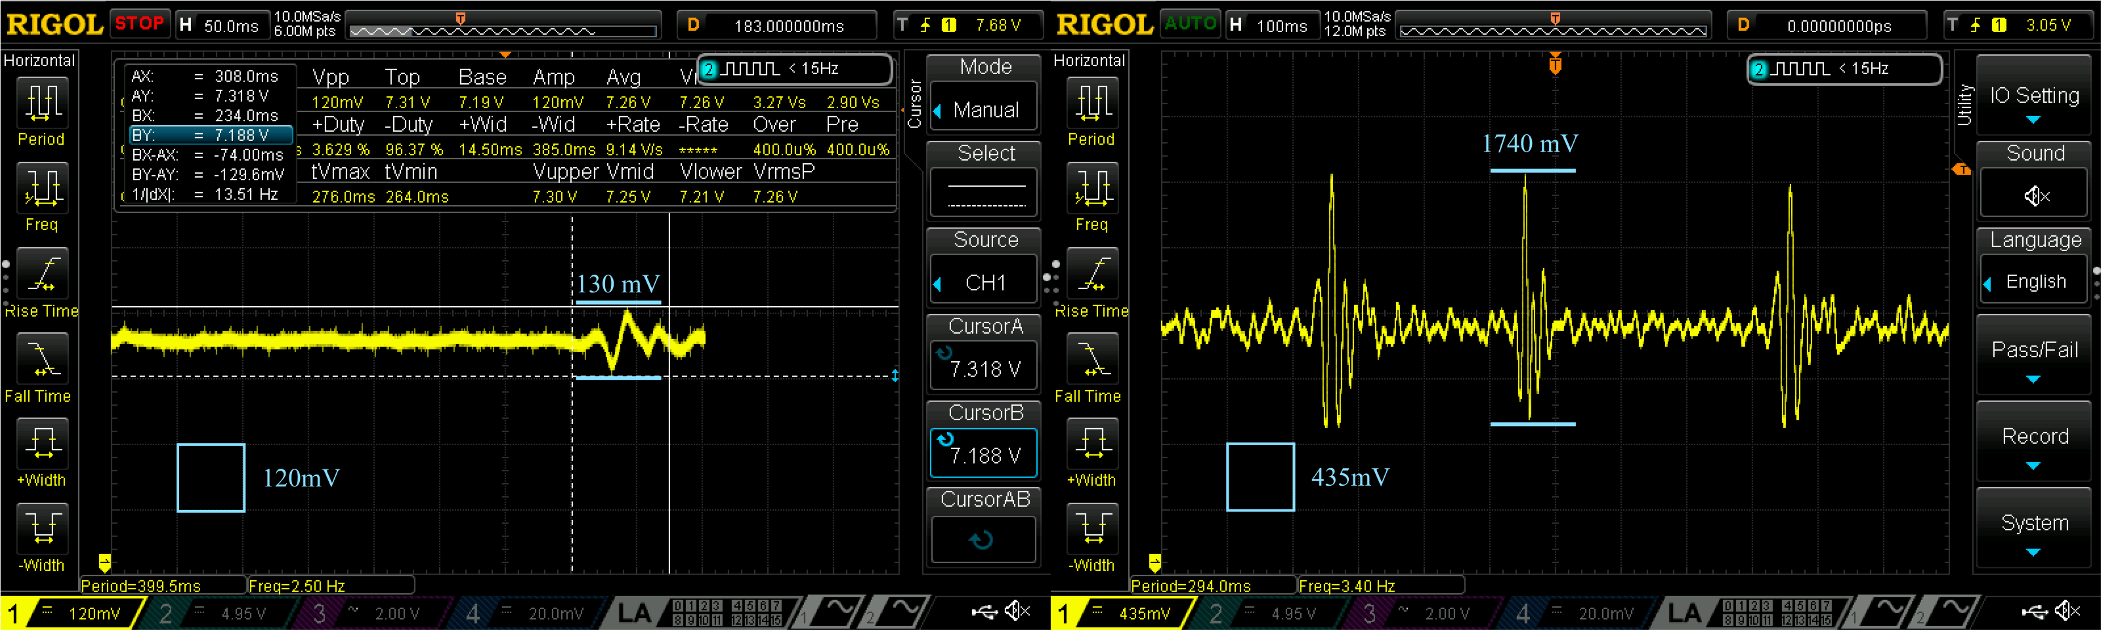

**Figure 9 Base Sound VS Amplified sound from the Oscilloscope**

* + 1. **Recorded Sound based Frequency Testing.**

We have tested the recorded sound from device successfully using digital sound recorder (Audacity. We visualised the recorded sound using spectrogram and the results were acceptable. The main band of the spectrogram lied below the 500Hz band and once filtered it lied below the 200Hz band.

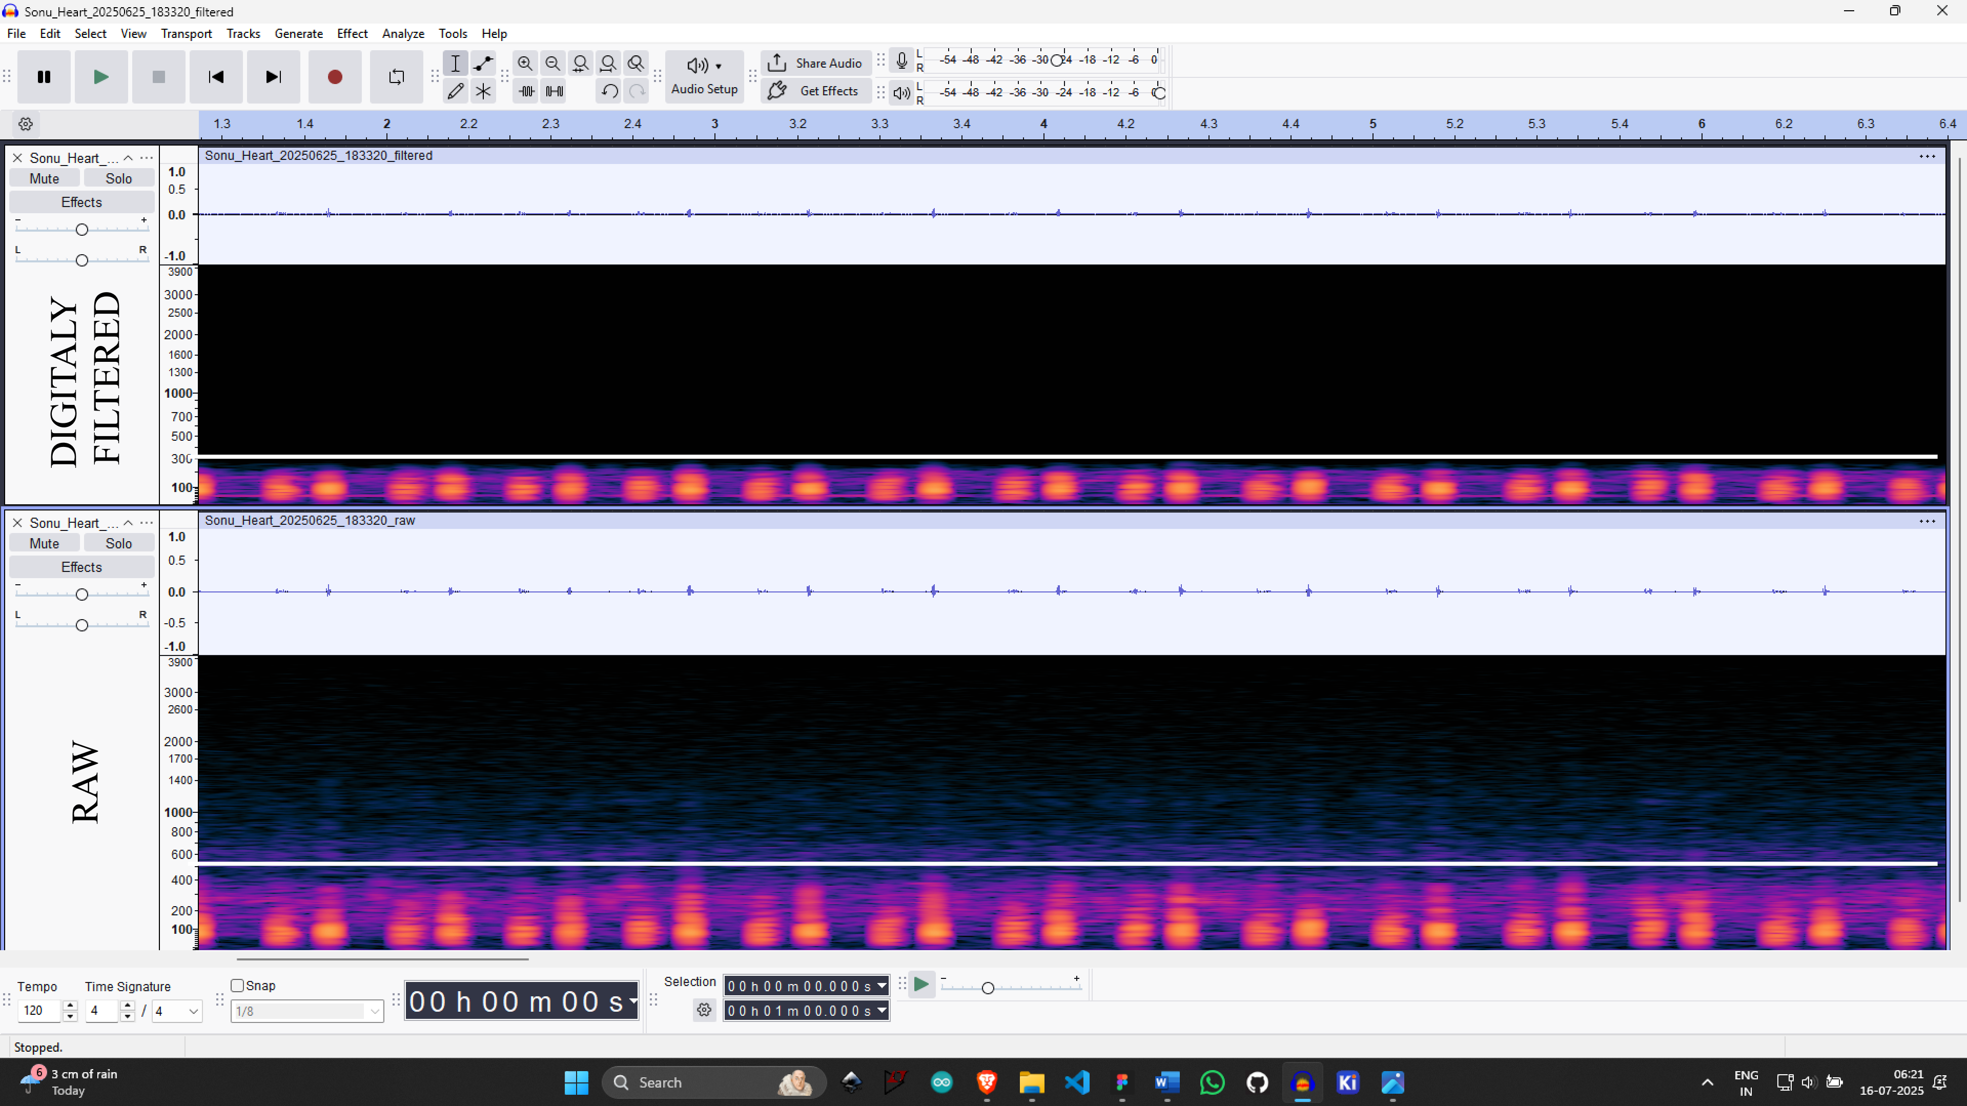

**Figure 10 Audacity based spectrogram viewer for the recorded sound analysis.**

The final device was successfully developed, assembled, and tested, meeting the desired performance criteria. Overall, the developed system proved to be functional, reliable, and ready for further application-specific deployment.

# **Chapter 5: Conclusion**

* 1. **Summery:**

**Design and Development:**

* A low-cost electronic stethoscope was designed for heart and lung sound monitoring, offering amplification, filtering, and recording features.
* A thorough literature review was conducted on stethoscope frequency parameters and market options, focusing on the need for accessible diagnostic tools.
* Device fabrication involved custom-designed analog circuits, adaptive noise cancellation using dual microphones, and a 3D-printed enclosure tailored for optimal acoustic performance.
* A dedicated Python-based software was developed for real-time sound visualization, recording, and basic digital filtering, with a user-friendly interface.

**Validation and Testing:**

* Hardware testing was conducted using a digital oscilloscope (Rigol DS1104), confirming significant signal amplification from 120 mV to approximately 1740 mV without distortion.
* Sound recording analysis via Audacity and spectrogram visualization confirmed proper capture of relevant frequencies, mainly below 500 Hz, with effective background noise reduction.
* The final assembled device demonstrated clear, amplified physiological sounds with dual-mode operation for heart and lung auscultation.
  1. **Conclusion:**

We successfully designed, developed, and validated an affordable electronic stethoscope capable of amplifying, filtering, and recording heart and lung sounds. The device combined efficient hardware design, 3D-printed enclosures, and custom software to deliver a reliable point-of-care diagnostic tool. Testing with oscilloscopes and audio analysis confirmed the device's ability to capture clean and clear physiological sounds, making it suitable for clinical training, telemedicine applications, and potential integration with AI-based diagnostic systems.

# **Chapter 6: Future Scopes**

The developed electronic stethoscope serves as a foundation for further enhancements to make it more versatile and clinically applicable. Future improvements can include:

* **Wireless Data Transmission:** Integration of Bluetooth or Wi-Fi modules to enable wireless audio streaming and remote monitoring via mobile applications or telemedicine platforms, eliminating the need for physical connections.
* **Digital Signal Processing (DSP):** On-board microcontroller-based DSP can be incorporated to perform real-time noise cancellation, adaptive filtering, and sound classification before transmission.
* **AI-Powered Diagnostics:** Development of machine learning algorithms for automatic detection of abnormal heart or lung sounds to assist in preliminary screenings and reduce diagnostic errors.
* **Multi-Organ Mode Expansion:** Expansion of the device to include additional auscultation modes, such as bowel or vascular sounds, broadening its clinical utility.
* **Rechargeable and Compact Design:** Further miniaturization and integration of rechargeable power sources with improved battery life to make the device more portable and user-friendly.

These advancements would enhance the practicality of the device, making it a more comprehensive, smart, and connected healthcare tool.

# **Chapter 7: Learnings from the project**

**Understanding of Biomedical Devices:** Gained in-depth knowledge of stethoscope design, human auscultation sounds, and the clinical importance of heart and lung sound monitoring.

**Literature Review Skills:** Learned how to systematically research and review existing devices, their features, limitations, and cost factors to identify gaps and design goals.

**Analog Circuit Design:** Developed hands-on skills in designing and implementing analog circuits using op-amps, instrumentation amplifiers, filters, and power management systems.

**PCB Designing and Fabrication:** Acquired practical experience in designing PCB layouts using KiCad, understanding component placement, routing, and preparing files for manufacturing.

**3D Modelling and Printing:** Gained proficiency in designing mechanical enclosures using software like SketchUp and fabricating them using 3D printing techniques.

**Software Development:** Learned to develop basic software in Python for data acquisition, real-time plotting, filtering, and storing physiological sounds with a user-friendly interface.

**Testing and Validation Methods:** Understood the process of validating medical devices through oscilloscope testing, sound spectrogram analysis, and performance benchmarking.

**Project Planning and Execution:** Improved project management skills, from ideation to execution, involving multidisciplinary knowledge in electronics, software, and biomedical applications.

**Problem Solving:** Enhanced troubleshooting skills by overcoming design challenges such as signal distortion, power supply limitations, and noise reduction techniques.

**Communication and Documentation:** Improved technical documentation and presentation skills by preparing project reports, diagrams, and software guides.

***ALL THE RESOURCES ARE AVAILABLE IN THIS*** [***GITHUB***](https://github.com/shreenandansonu/Electronic-Stethescope) ***PAGE.***

***https://github.com/shreenandansonu/Electronic-Stethescope***